Junk File Organizer

**Aim**

The aim of this project is to build a python program that runs as a command-line tool. Basically, as a lazy programmer, my desktop is full of files as shown below. Due to a large number of files, it is a daunting task to sit and organize each file. To make that task easy, we need a Python script that comes in handy and returns a folder where all the files are organized in a well-manner within seconds. It should organize by size, last used or even extensions.

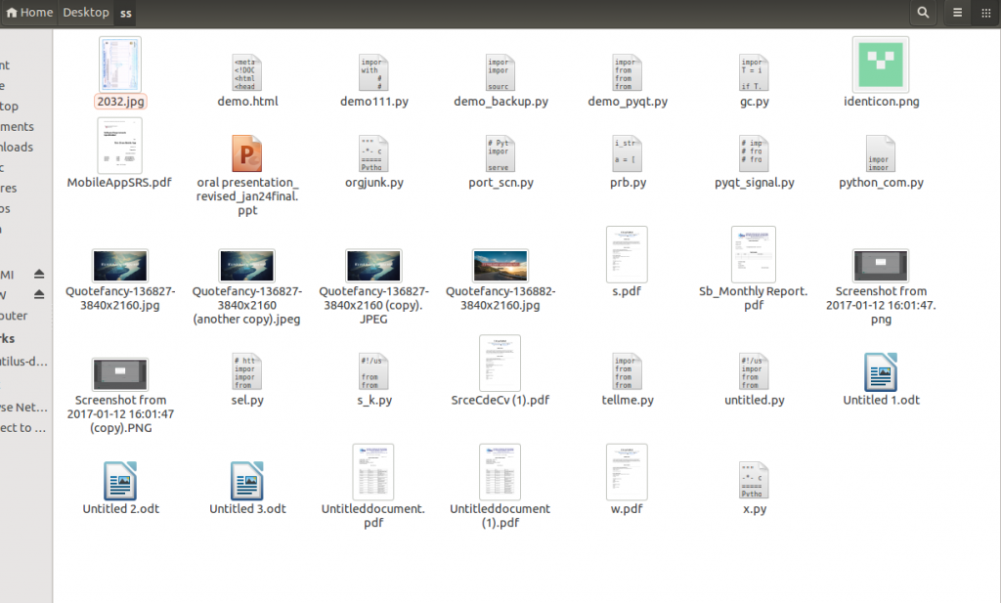

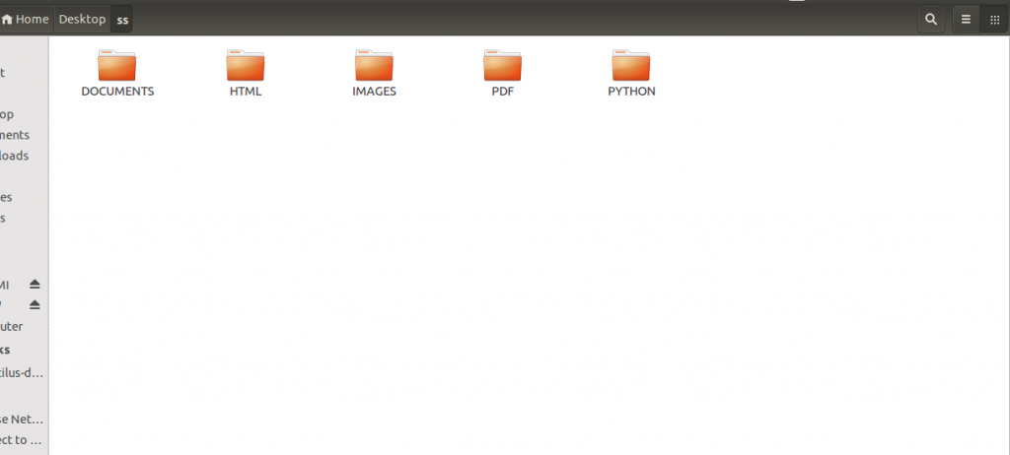

**Requirements**

A clear understanding of [command-line parsing](https://www.youtube.com/watch?v=0twL6MXCLdQ), [file handling](https://www.youtube.com/watch?v=ixEeeNjjOJ0), [recursion](https://www.geeksforgeeks.org/recursion/), os module in python and symbolic linking(in Linux) as it is not possible to copy-paste the content of these files all the time.

**Deliverables**

1. Command-line interface for Linux and/or Windows
2. A 500-word report describing your approach/code to be uploaded on GitHub in the README.MD file of your repo.

**junkfileorganizer [-d directory] [-o option]**

-o how to organize the files, based on extensions, file size, date modified

**Recommended Approach**

Use os module of python to recursively list out all the files that are present in the folders with their relative and absolute path then create a new folder with the parent called ***organized*** which will contain all the files in organized sub-folders.

**Some Sample Code**

Take the input in the file as the absolute path of the folder to be organized and the criterion to classify on as command-line inputs. Return the path of the organized folder.

<https://www.geeksforgeeks.org/junk-file-organizer-python/>

<https://www.tutorialspoint.com/junk-file-organizer-in-python>

<https://www.tutorialspoint.com/listtutorial/How-to-Delete-Junk-Files/4278>